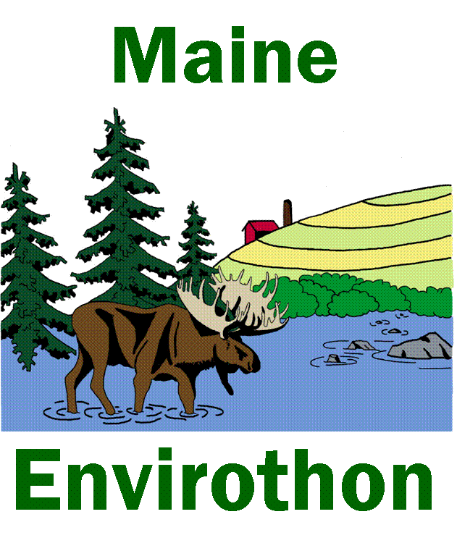
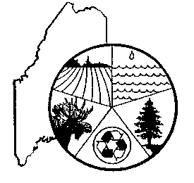
MAINE ASSOCIATION OF CONSERVATION DISTRICTS
Education and Envirothon Committee

Dale Finseth - MACD Education Program Coordinator
Kennebec County Soil & Water Conservation District
50 Hospital St.
Augusta, Me 04330

January 2020
Dear Educator / Envirothon Advisor:

I am writing to invite you and your students to participate in the 2020 Maine Envirothon. Last year, we had over 50 teams from high schools/home schools throughout Maine participate. We look forward to seeing these veteran schools again in 2020 and welcome new schools to take part in this valuable learning experience.

Envirothon is a state- and nation-wide environmental competition where high school students test their knowledge of natural resources and current environmental issues. Teams consisting of 3-5 students compete initially at a regional level, answering questions and solving hands-on problems at five topical stations: Wildlife, Aquatics, Forestry, Soils, and a Current Natural Resource Issue. The 2020 Current Issue topic is Water Resource Management: Local Control and Local Solutions. Maine will be tailoring this topic to fit our northeast ecosystem. The top finishing teams from each Regional Envirothon then compete at the State Finals on Friday, May 29th at the Bond Brook Recreation Area in Augusta. The state’s winning team will travel to the University of Nebraska in Lincoln, Nebraska July 28- August 1, 2020 for the International Competition.

Envirothon is an academic program that is aligned with standards-based learning. As well as advising teams for competition, teachers throughout Maine successfully incorporate Envirothon concepts and hands-on activities into their science curricula. The program raises students’ awareness of local and national environmental issues. Envirothon integrates math, language arts, cultural land-use history, and science in ways unique to the field. Students build critical thinking and decision-making skills as they practice solving real environmental problems.

In addition to learning about the environment, applying knowledge, collaborating to address natural resource issues, and meeting other young students from around the state and nation, Maine participants are eligible for scholarships from the College of Natural Sciences, Forestry, and Agriculture at the University of Maine, Orono. Winners of the National Envirothon receive individual college scholarships. Through this program, students have an opportunity to meet and learn from state soil scientists, biologists, foresters, and other natural resource professionals.

We greatly appreciate advisors’ interest in natural resources, commitment to environmental education, and time spent preparing teams for competition. As an Envirothon team advisor, it is not necessary that you be an expert in environmental areas or be a full-time teacher. Natural resource professionals from Maine’s 16 Soil and Water Conservation Districts may be available to assist teams with resource materials and preparation. If you are interested in the program but are not yet ready to form a team for competition, please contact us for more information and an opportunity to attend a preparatory Fall Field Day hands-on training session or the Forestry & More Workshop in the winter. Please note that advisors can be teachers, parents, and/or community members.

The deadline for registration is March 20, 2020. To receive your coveted Maine Envirothon team t-shirts, we need registration by this date! Once your team is registered, we will send you additional information and a resource packet to guide preparation for the Regional Envirothon. You will be notified about workshops and/or hands-on training sessions for your team. Please register as soon as possible to ensure you receive this information with plenty of time to study and practice. However, there will be NO REFUNDS once a team has registered if the team has to cancel.

Please mail your registration form and fee(s) made payable to MACD State Envirothon to: MACD State Envirothon, c/o Dale Finseth, Fiscal Manager KCSWCD – 50 Hospital St, Augusta ME 04330. Please contqct me by e-mail or phone so I know to expect it.

ON-LINE registration and payment is also available. If you would like to register on-line go to; www.maineenvirothon.org/registration and follow the instructions.
- The www.knox-lincoln.org website offers a link, so you can both register and pay the registration fee using a credit card or PayPal
- Send in your registration form by mail to above address and pay with credit card at www.knox-lincoln.org/enthon-reg or
- Upload your registration form and pay with credit card at www.knox-lincoln.org/enthon-reg

You may contact me with questions at 207.621-9000 or email me at dale@kcswcd.org. I look forward to receiving your registration packet and seeing your team at Envirothon!

Dale Finseth, MACD Education Program Coordinator/Contact

MAINE SOIL AND WATER CONSERVATION DISTRICTS
Many are co-located with USDA – NATURAL RESOURCES CONSERVATION SERVICE OFFICES

Androscoggin Valley
254 Goddard Road - PO Box 1938
Lewiston, ME 04241-1938
Phone: 753-9400 x3; Fax: 783-4101
DistrictManager@AndroscogginSWCD.org

Central Aroostook
735 Main Street Suite #3
Presque Isle, ME 04769
Phone: 760-4604; Fax: 764-4753
CentralAroostookSWCD@gmail.com

Cumberland County
35 Main Street
Windham, ME 04062
Phone: 892-4700; Fax: 892-4773
Info@Cumberlandswcd.org

Franklin County
107 Park St
Farmington, ME 04938
Phone: 778-4279;
rosetta.thompson@franklincswcd.org

Hancock County
192 State Street, Suite 11
Ellsworth, ME 04605
Phone: 667-8663; Fax: 667-3585
LLichko@HancockCountySWCD.org

Kennebec County
50 Hospital St.
Augusta, ME 04330
Phone: 621-9000
Dale@kcswcd.org

Knox-Lincoln
893 West Street, Suite # 103
Rockport, ME 04856
Phone: 596-2040;
Rebecca@Knox-Lincoln.org

Oxford County
17 Olson Road
South Paris, ME 04281
Phone: 744-3119;
OxfordCountySWCD@gmail.com

Penobscot County
1423 Broadway, Suite 2
Bangor, ME 04401
Phone: 990-3676 x3; Fax: 992-1782
Amy.Polyot@PenobscotSWCD.org

Piscataquis County
42 Engdahl Drive
Dover-Foxcroft, ME 04426
Phone: 564-2321 x3
info@PiscataquisSWCD.org

St John Valley
139 Market St, Suite 106
Ft. Kent, ME 04743
Phone: 834-3311 x3; Fax: 834-6435
SJVSWCD@gmail.com

Somerset County
70 East Madison Road
Skowhegan, ME 04976
Phone: 474-8323;
info@somersetswcd.org

Southern Aroostook
304 North St
Houlton, ME 04730
Phone: 532-9407 or 254-4126
Angela.Wotton@me.nacdnet.net

Waldo County
46 Little River Drive
Belfast, ME 04915
Phone: 338-1964; Fax: 338-4972
aleta.waldosoilandwater@gmail.com

Washington County
PO Box 121 -
Machias, ME 04654-0121
Phone: 255-4659;
Nate.Pennell@myfairpoint.net

York County
21 Braden Street Suite 304
Springvale, ME 04083
Phone: 324-0888; Fax: 324-4462
MelissaBrandt@YorkSWCD.org

2020 MAINE ENVIROTHON REGISTRATION

HIGH SCHOOL: ______________________________________________________________________
NUMBER OF TEAMS REGISTERED _________
TEAM ADVISOR: ____________________________________________________________________

SCHOOL ADDRESS: __________________________________________________________________
TOWN/STATE/ZIP: ___________________________________________________________________

SCHOOL PHONE: __________________CELL PHONE DAY OF EVENT____________________

EMAIL-School: _____________________________ EMAIL-Home:___________________________

PLACE ONE CHECK BELOW NEXT TO THE REGIONAL COMPETITION YOU WANT TO ATTEND. ON THE PORTION BELOW, INDICATE YOUR SECOND CHOICE (LIMIT 20 TEAMS PER REGION).

Northern Regional: Tuesday May 19th @ Riverfront Park, Houlton ___
Midcoastal Regional: Wednesday May 20th @ MOFGA [Maine Organic Farmers & Gardeners Assoc], Unity ___
Southwestern Regional: Thursday May 21st @ Valentine Farm Conservation Area, Bethel ___
Downeast/Central Regional: Friday May 22nd @ Leonards Mills, Bradley ___

THIS PORTION MUST BE COMPLETED BY ADVISORS

Because there will be a limit of 20 teams per regional competition, please indicate below your second choice for the regional competition you would like to attend. This will only apply if you register after 20 other teams have already registered for your first-choice location. Shortly after you register, you will be notified as to your choice of regional competitions.
2nd CHOICE (Check one)
Northern___________ Midcoast_________
Southwest________ Downeast/Central _______

REGISTRATION FEE: $125 PER TEAM.
This fee covers the regional event as well as the state finals if your team is a finalist. One team will advance to the State Envirothon for every five teams that participate in a given regional. Please note that there will be NO REFUNDS once a team has registered. In addition, there are no roll over credits to future Envirothons if the team has to cancel.

PLEASE MAKE CHECK PAYABLE TO: MACD State Envirothon
MAIL THIS FORM AND FEE(S) TO: Maine State Envirothon Fiscal Manager
c/o Dale Finseth, Fiscal Manager
KCSWCD – 50 Hospital St. Augusta, ME 04330
OR --
ON-LINE REGISTRATION CAN BE DONE BY VISITING AND FOLLOWING THE INSTRUCTIONS ON-LINE!! PayPal/Credit Card at http://www.knox-lincoln.org/enthon-reg/

If you would like to pay with a credit card:
- Send in your registration form by mail to above address and pay with credit card at www.knox-lincoln.org/enthon-reg
- Upload your registration form and pay with credit card at www.knox-lincoln.org/enthon-reg

SHORTLY AFTER REGISTRATION, WE WILL EMAIL A TEAM RESOURCES PACK (STUDY GUIDE) AND REFERENCE MATERIALS. TEAMS WILL ONLY RECEIVE THESE MATERIALS IF A REGISTRATION CHECK ACCOMPANIES THIS FORM OR AN ON-LINE PAYMENT HAS BEEN TRANSACTED. UNLESS YOU STATE OTHERWISE, WE WILL ONLY EMAIL THE RESOURCE PACKET.
- YES, I WOULD LIKE TO RECEIVE A HARD COPY OF THE
RESOURCE PACKET TO THE ADDRESS ABOVE!
FINAL DEADLINE FOR REGISTRATION: MARCH 20, 2020.

For additional information, contact your local Soil and Water Conservation District (see attached list).
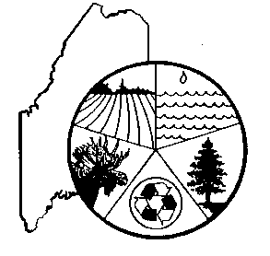
Name of High School___________________________________
# of TEAMS ______
Names of Confirmed Team Members (if available). It is not essential to list all names of your team members on this form. However, if you are sure of the members, fill in this section.

If you will be bringing more than 2 teams, include names on a separate sheet of paper.

TEAM I TEAM II.
1. _________________________________________ 1. ______________________________________

2. _________________________________________ 2. ______________________________________

3. _________________________________________ 3. ______________________________________

4. _________________________________________ 4. ______________________________________

5. _________________________________________ 5. ______________________________________

6. Alternate: ________________________________ 6. Alternate: _____________________________

T-SHIRT ORDERS

Each team receives 6 Envirothon short sleeve t-shirts as part of the registration fee if registration is received by March 20, 2020. T-shirts are 100% cotton.

Available sizes are small, medium, large, x-large and xx-large. A check must accompany the order.
PLEASE INDICATE YOUR TEAMS' T-SHIRT SIZES (write total number of shirts next to each size)

All Short Sleeve _____SMALL _____MEDIUM _____LARGE _____X-LARGE _____ XXL

If you are ordering additional t-shirts for team member(s) or advisors, a check must accompany this order.
_______________Amount enclosed for additional t-shirts at $10.00 per shirt. Indicate sizes above.

GENERAL ENVIROTHON INFORMATION

Forming a Team: A team consists of a minimum of 3 students but no more than 5 students plus an alternate in grades 9-12. Interested students from a class may form teams or they may be members of a club. Team members must live in the same school district. Home school students are welcome too. Every school can send multiple Envirothon teams to regional competitions. The teams must attend the same regional competition.
Registering a Team: Registration materials are mailed to every high school no later than December of the prior year. The registration fee is $125 per team. There are 4 regional competitions from which to choose and all competitions are held in late April or May. Teams can choose whichever regional competition they wish to attend. No more than 20 teams can participate at a regional competition. Therefore, teams who register early can be guaranteed their choice of regional competitions. A team would have to attend their second choice for the regional competitions if they are the 21st team to register for a particular region. Schools with two or more teams must attend the same regional competition.
Once registered, teams receive a Team Resource Pack from which to study. Approximately 4 weeks before the regional competitions, the Soil & Water Conservation District hosting the regional competition will send you an email containing information about the competition and a map showing you how to get to the site. One team will advance to the State Final for every 5 teams that participate in the given regional competition. The top state team attends the North American Envirothon National competition.
At the competitions, teams receive t-shirts that were ordered. Additional t-shirts may be ordered/purchased when a team registers. Usually, but not always, lunch is provided at the competitions. Lunch is provided at the state finals, the location of which changes yearly.
Please note there are NO REFUNDS if a school cannot make it once a team has registered, nor can the registration fee be rolled over to the following year, if the team has to cancel.
Testing Time/Stations: At the regional and state competitions, teams are tested for 30 minutes in an outdoor setting at each station (site): soils, aquatics, forestry, wildlife and a current issue. The current issue changes yearly. Occasionally, the testing time is extended to 40 minutes if there are more than 3 teams per station.
Types of Tests: Tests vary from station to station. Most tests include some multiple-choice questions, fill-in-the-blank, short explanations, and problems to solve. Judges try to make each test as site-specific as possible and hands-on activities/skills are included. Testing at the Current Issue station is conducted differently. Once a team registers for a regional competition, the team receives a problem to solve related to the Current Issue. Every team creates a poster(s) in advance which they bring to the regional competition. The poster should contain information about the problem they tried to solve. At the regional event, each team makes a 5-minute oral presentation in front of the judges explaining how they solved the problem. Judges may ask the team questions if time permits, not to exceed two minutes. At the State Final, oral Presentations are extended to 7-minutes with a 2-minute question period by judges. When registered, all teams receive an extensive packet of reference materials for the Current Issue and oftentimes other references recommended by judges.
Reference Materials Used to Study For Tests: Most Soil and Water Conservation Districts have copies of the reference materials that students are asked to study for the competitions. A list of references is included with each study packet. Reference materials include websites, pamphlets, books, brochures, magazine articles, government publications and videos. Most are free or inexpensive.
Regional Workshops: Regional workshops or Fall Field Day events for teams will be during the fall and winter. When you register for the Envirothon, you will be notified of these workshops and training sessions. There will be a Forestry Workshop held in March at Unity College. If you feel that you or your team need additional help studying for the tests, contact your local Soil and Water Conservation District and ask if they know a resource specialist who may be of assistance.
Advisors/Alternates: Each team must have an adult advisor(s). Advisors may be teachers, parents, or members of the community. Advisors assist the teams in preparing for the competitions and make the necessary arrangements regarding registration, transportation, and when/ where/and how frequently team members will meet. Advisors help students determine the most desirable way to study for the competitions. Advisors and alternates are not allowed to visit testing stations before their team(s) is tested at that station. Some advisors chose to bring work with them. At some regional competitions, the host district provides educational activities for the advisors. Each team is allowed to bring one alternate per team. Alternates may stay with their advisors during the testing. Additional individuals are discouraged from accompanying the teams to the competitions. They must ask the host district for permission to attend and may be charged a luncheon fee. At the State Finals, advisors are not allowed to accompany the teams through the competition. Educational programs for advisors may be planned, however. Student cell phones/pagers WILL BE COLLECTED BY ADVISORS at both regional and state competitions.
Rules and Regulations: Non-adherence to the rules and regulations may lead to a team's disqualification. For additional information, contact your local Soil & Water Conservation District or Dale Finseth, MACD Education Program Coordinator: 207.621-9000 or email at Dale@kcswcd.org.

If selected as the Maine State Envirothon Team: If your team is selected to represent Maine at the international competition, MACD will assist the team with materials and the cost of registering for the competition. However, the winning team will be responsible for arranging and paying for the costs of attending the competition. Recognize that this expense may be substantial given the location of the international competition. MACD continues to work on fundraising to assist the winning team with the costs of attending, however MACD can only commit to the cost of registering the team.

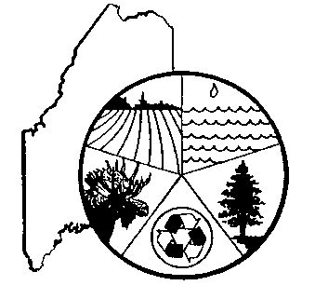
MAINE ENVIROTHON PROGRAM
Maine Association of Conservation Districts, Education and Envirothon Committee

Dale Finseth, MACD Education Program Coordinator/Contact
Kennebec SWCD
50 Hospital St.
Augusta, Me 04330
207-621-9000

2020 ENVIROTHON ▪ HOST CONTACTS ▪ REGIONAL COMPETITIONS ▪ DATES/SITES
Northern Regional- Angie Wotton. Southern Aroostook SWCD Angela.Wotton@me.nacdnet.net May 19th Riverfront Park, Houlton
MidCoast Regional- Jenny Jurdak, Waldo SWCD; Jenny.Jurdak@me.nacdnet.net May 20th MOFGA, Unity
Southwestern Regional –Jean Federico; Oxford SWCD; OxfordCoundySWCD@gmail.com May 21st Valentine Farm, Bethel
Downeast/Central Regional- Nate Pennell, Washington SWCD; Nate.Pennell@myfarirpoint.net May 22nd ; Leonard’s Mills, Bradley

STATE FINALS: MACD Envirothon Committee, Dale Finseth 621-9000 Dale@kcswcd.org May 29th at Bond Brook Recreation Area in Augusta

RECOMMENDATIONS AND EXPECTATIONS
For the sake of equity, honesty and fairness to all Envirothon teams, the State Envirothon Committee recommends the following:
- Advisors and teams should not visit the location of regional or state competition sites within a week prior to the competitions. On the day of the competitions, teams are asked to remain in the reception/registration area until the beginning of the competition.
- No less than 3 but no more than 5 team members, 1 alternate and 1 or 2 advisors/chaperons should be present at the Envirothon competitions. Other individuals who are interested in attending any of the competitions must obtain prior approval from the host district for regional competitions and the state coordinator for the finals. Fees for meals may be charged for any additional individuals in attendance.
- Honesty and ethical conduct is expected of all teams. While teams are discussing answers to test questions at the station, care should be taken that other teams do not hear these discussions.

RULES AND REGULATIONS
- Competitors must be enrolled in grades 9 through 12 or equivalent at the time of registration.
- Each team will have a minimum of three and a maximum of five team members. You may have only one alternate per team for regional and state competitions, but no more than five members compete. These same three to five team members compete during the entire competition and at the regional and state competitions. The alternate may not substitute unless one of the members becomes incapacitated at an event or if one team member is unable to attend the state competition. The alternate does not have to be present at the regional competition and his/her name must appear on the regional competition's team roster.
- All team members must be from the same school. (No regional all-star teams)
- Each team must have an adult advisor. During the competition and while students move between stations, the advisor(s) and alternates cannot assist or communicate with their team in any way and must stay at least 20 feet from their team(s) during the testing. Non-adherence will result in the advisor and/or alternate not being allowed at any remaining test sites during the competition. No advisors will be allowed to accompany the teams through the competition at the State Finals.
- Judges' decisions are final on all events.
- Transportation to and from competition will be the responsibility of each team. IF YOU ARE HAVING TROUBLE WITH TRANSPORTATION OR OTHER COSTS, SEE IF YOU CAN GET A LOCAL SPONSOR TO HELP OUT.
- One team will advance to the State Final for every 5 participating teams that compete in a given regional. Non-competing teams will not count. A minimum of two teams will advance regardless of how many teams are participating. Numbers will be rounded up or down to determine the advancing schools. (Ex. 12 teams – 2 teams would qualify for States; 13 teams – 3 teams would qualify).
Any number of teams may compete from one school at regional events. A local home school chapter is equivalent to one school.
- At each regional event, the first team out of state qualification will be considered the alternate team to participate at the State Event if one of the top regional teams drops out. Only the “first out” team will be the alternate, no matter how many teams drop out ahead of them for that region.
- Each team may include only 1 alternate. Additional students accompanying a team will not be permitted to participate in Envirothon even informally, and should therefore not be in attendance. There will be NO alternate teams at the state finals.
- High schools with 2 or more Envirothon teams must attend the same regional competition.
- No team or team member will be allowed to leave the testing area while tests are being administered without judge’s approval.
- There will be no refunds or rollover to future Envirothon’s once a team has registered if they must cancel.
- Cell phones/pagers must be given to the advisor during competitions.
- Cameras are not allowed by either students or advisors during any regional or state competition.

For a complete and up-to-date list of rules and regulations, please refer to the Maine Envirothon website at www.maineenvirothon.org

